Ch. 8 Circulatory System
**BEFORE LECTURE Define the following word parts: Word Part quiz will be __________________________________
Prefixes | Combining Forms |  | Suffixes
De- | Aden(o) | Myocardi(o) | -ole
 | Adenoid(o) | Ox(i) | -sclerosis
 | Aneurysm(o) | Pericardi(o) | -stenosis
 | Angi(o) | Phleb(o)
 | Aort(o) | Pulmon(o)
 | Arter(o), ateri(o) | Rhythm(o), rrhythm(o)
 | Arteriol(o) | Sclera(o)
 | Ather(o) | Sept(o)
 | Atri(o) | Sin(o)
 | Cardi(o) | Splen(o)
 | Coron(o) | Steth(o), thorac(o)
 | Embol(o) | Thym(o)
 | Endocardi(o) | Tonsill(o)
 | Lymph(o) | Valv(o), valvul(o)
 | Lymphaden(o) | Vas(o), vascul(o)
 | Lymphangi(o) | Ven(i), ven(o)
 | Lymphat(o) | Ventricul(o)
 | Mediastin(o) | Venul(o)

**BEFORE LECTURE Define the following Abbreviations: Abbreviation quiz will be _____________________________

AI
ASHD
AV, A-V
AVB
BP
CABG
CAD
CHF
CK (CPK)
CPR
CVA
DSA
EMS
HDL
HTN
LA
LDH
LDL
LV
MI
MIDCAB
mm Hg
MVP
OPCAB
PAT
PCI
PDA
PTCA
PVC
RA
RV
SA
TEE

8.1
Functions of the Cardiovascular System

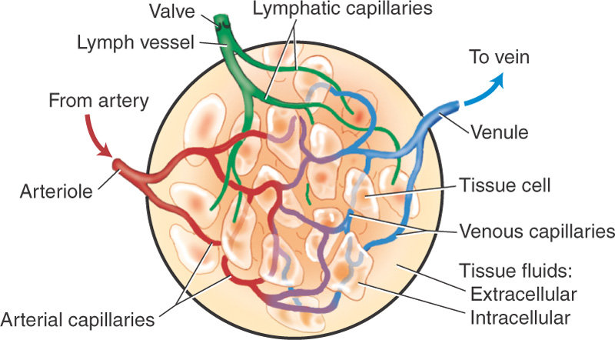
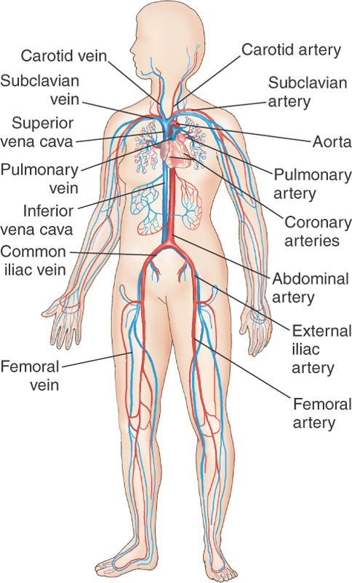

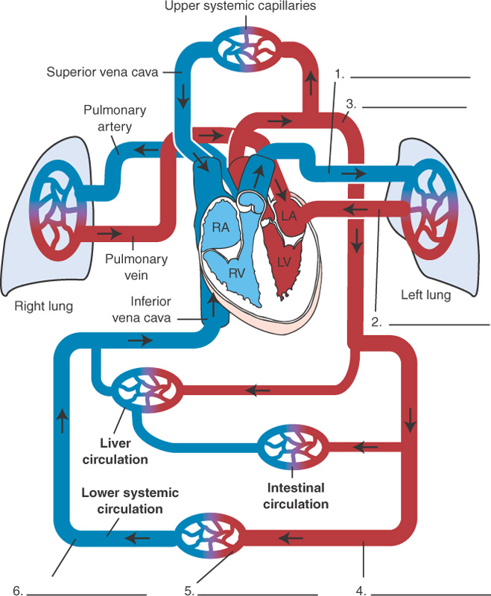

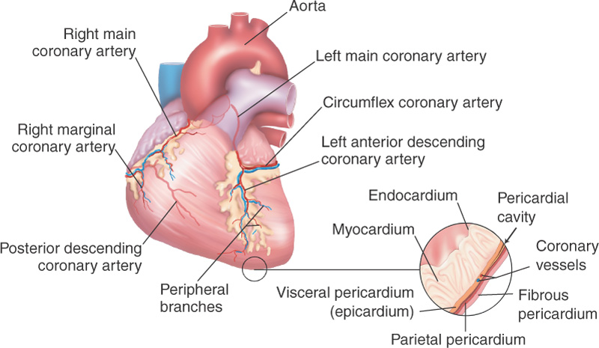

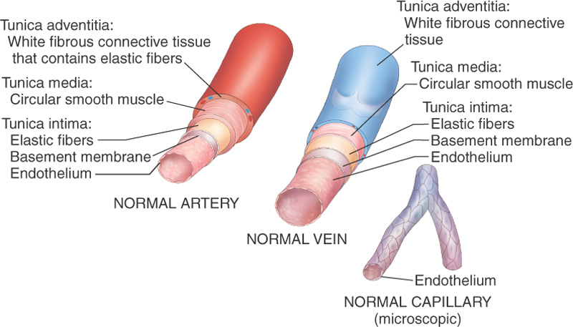

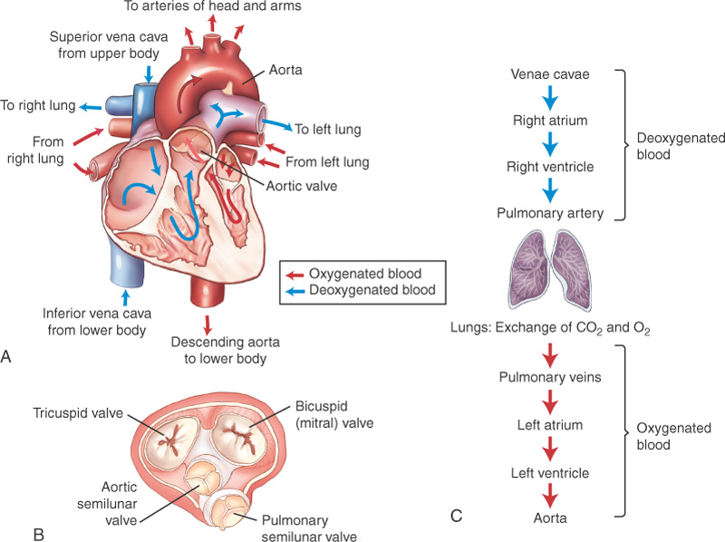

- Heart Rate
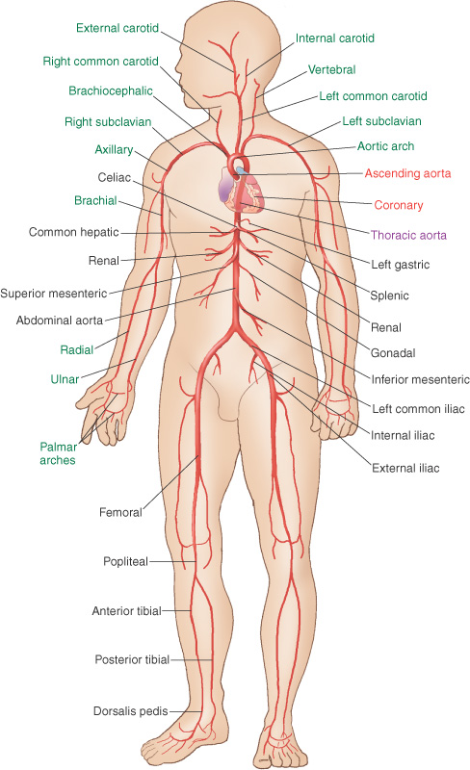
- Bradycardia
- Tachycardia
- Blood Pressure
- Systolic
- Diastolic
- Sphygmomanometer
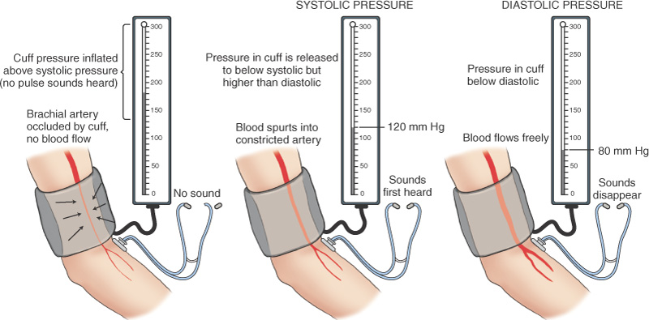
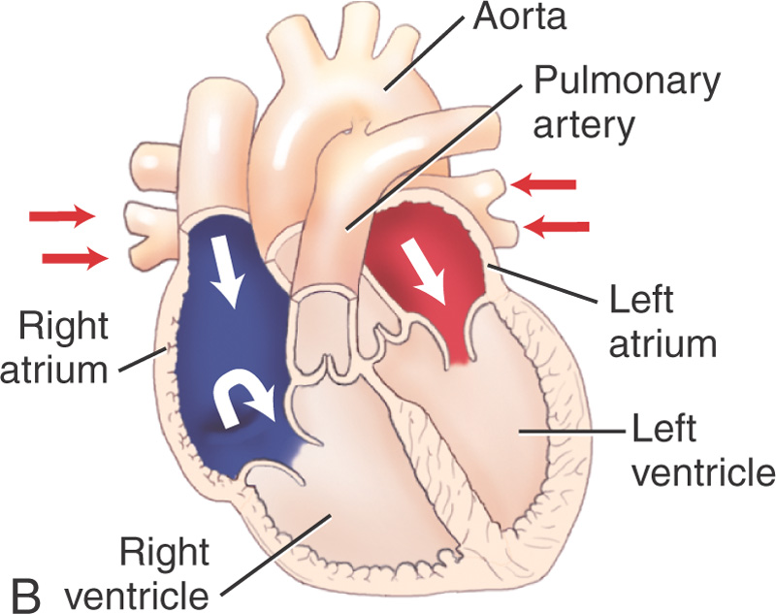
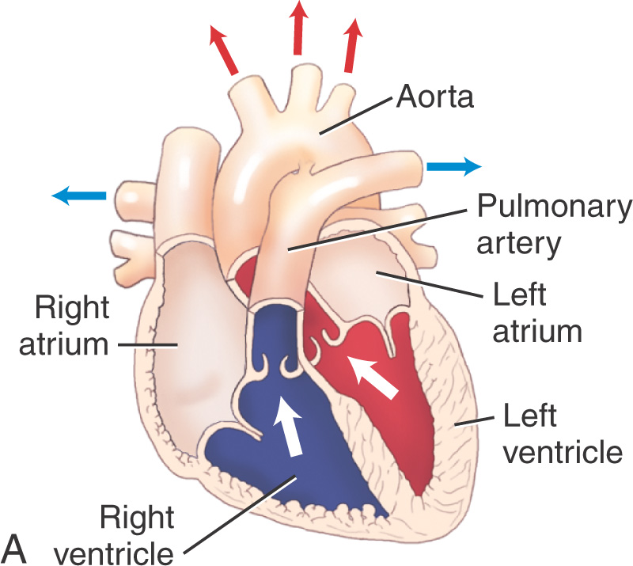

Laboratory Tests
- Lipids
- Cholesterol
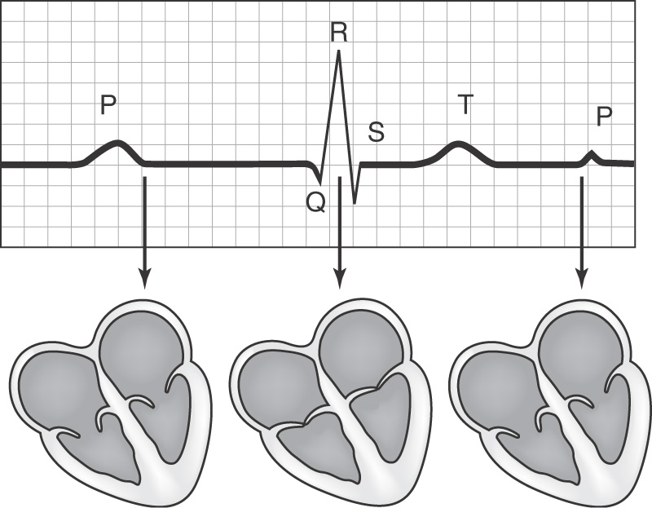
- Triglycerides
- Lipoproteins
- Enzymes
Diagnostic Test Terms
- Electrocardiography
- Electrocardiograph
- electrocardiogram
- Holter monitor
- chest X-ray
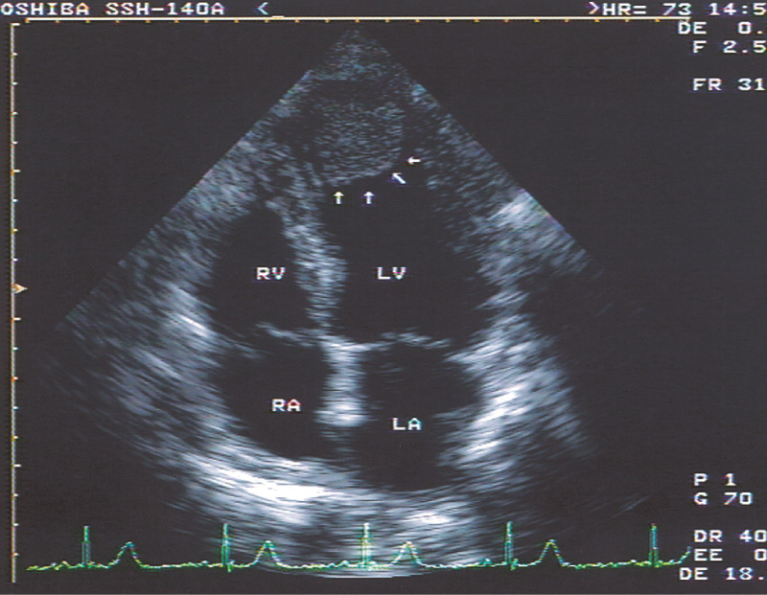
- treadmill exercise test
- thallium stress test
- Doppler echocardiography
- Doppler scanning
- cardiac MRI
- computed tomography
- positron emission tomography
- echocardiography
- echocardiogram
- Arteriography
- Arteriograph
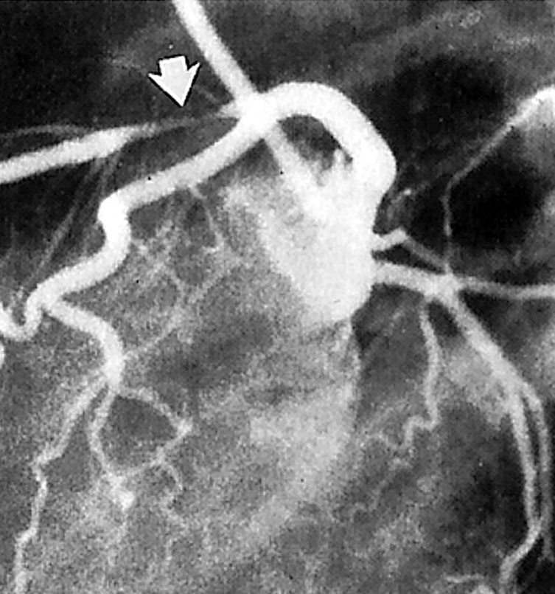
- arteriogram
- coronary arteriography
- aortography
- aortogram
- digital subtraction angiography (DSA)
- electrophysiologic studies
- cardiac catheterization
- angiogram, angiography
- angiocardiography
Heart Pathologies

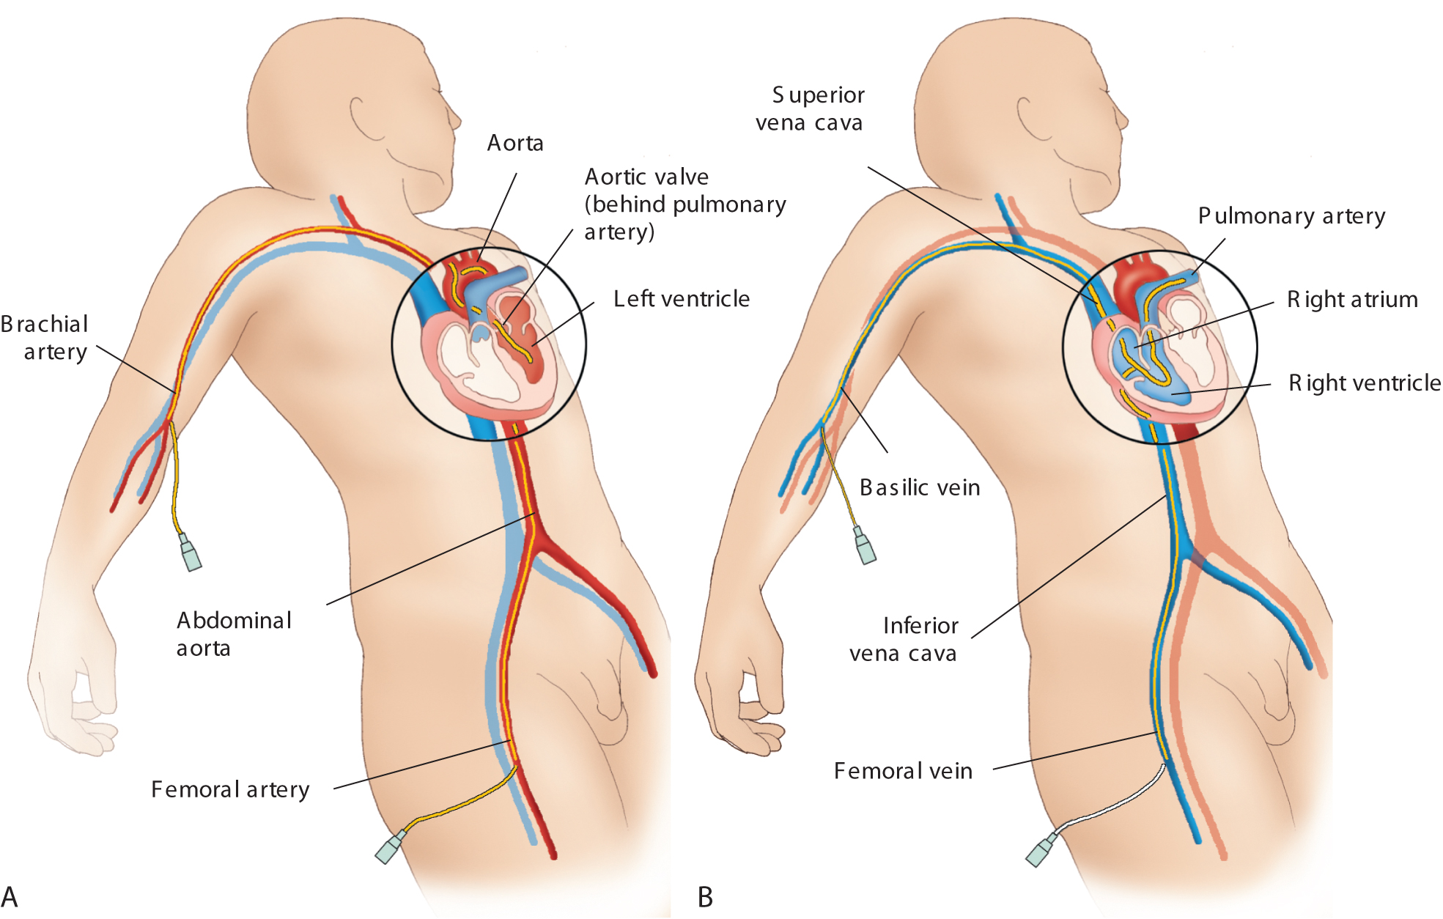
- Atriomegaly
- Cardiomegaly
- microcardia
- congenital heart disease
- congenital heart defects
- heart murmurs
- cyanosis
Congenital Heart Defects
- ventricular septal defect
- atrial septal defect
- patent ductus arteriosus (PDA)
- coarctation of the aorta
- tetralogy of Fallot
Arrhythmias
- dysrhythmia
- heart flutters
- heart palpitations
- ventricular fibrillation
- atrial fibrillation
- Bradycardia
- tachycardia
- premature ventricular contractions (PVC)
- paroxysmal atrial tachycardia (PAT)
- atrioventricular block (AVB)
- heart block
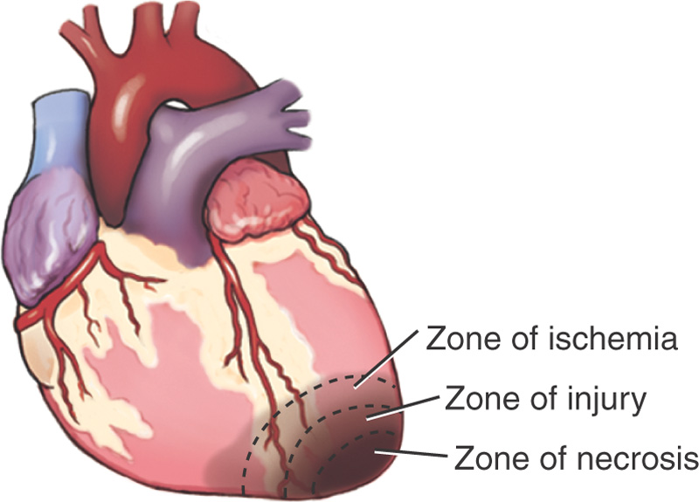
- asystole
Heart Pathologies Cont
- myocardial infarction (MI)
- anoxia
- infarct
- congestive heart failure (CHF)
- ischemia
- angina pectoris
- cardiac insufficiency
- hemopericardium
- effusion
- cardiac tamponade
- shock
- hypovolemia
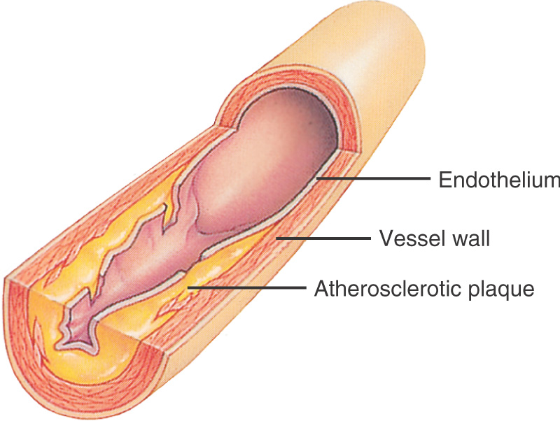
- cardiomyopathy
- myocarditis
- endocarditis
- pericarditis
Valvular Pathologies
- valvular stenosis
- valvulitis
- cardiovalvulitis
- mitral valve prolapse (MVP)
- rheumatic heart disease
Blood Vessel Pathologies
- coronary artery disease (CAD)
- arteriosclerotic heart disease (ASHD)
- atherosclerosis
- lumen
- occlusion
- Sclerosis
- aortosclerosis
- coronary thrombosis
- coronary occlusion
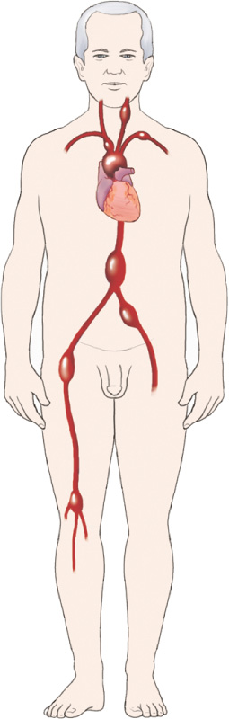
- cerebrovascular accident (CVA)
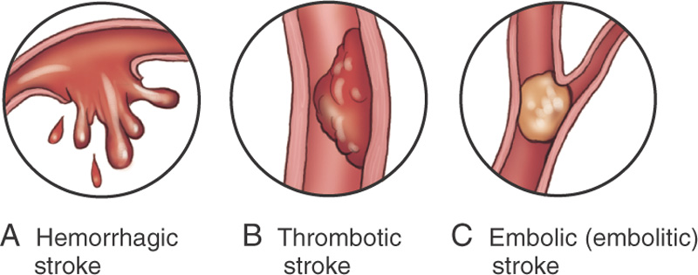

- stenosis
- stricture
- aortic stenosis
- aortic insufficiency (AI)
- aortic regurgitation
- Aortitis
- Angiocarditis
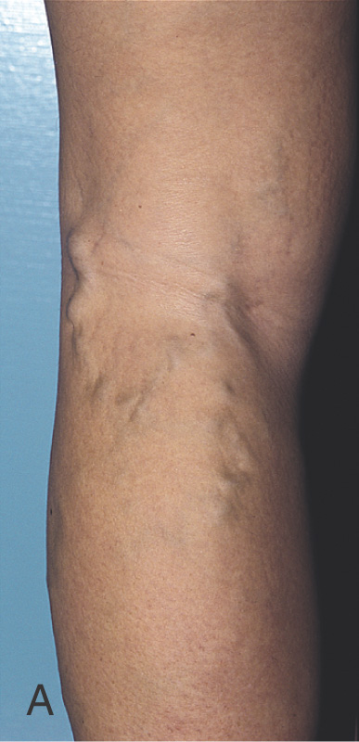
- arteritis
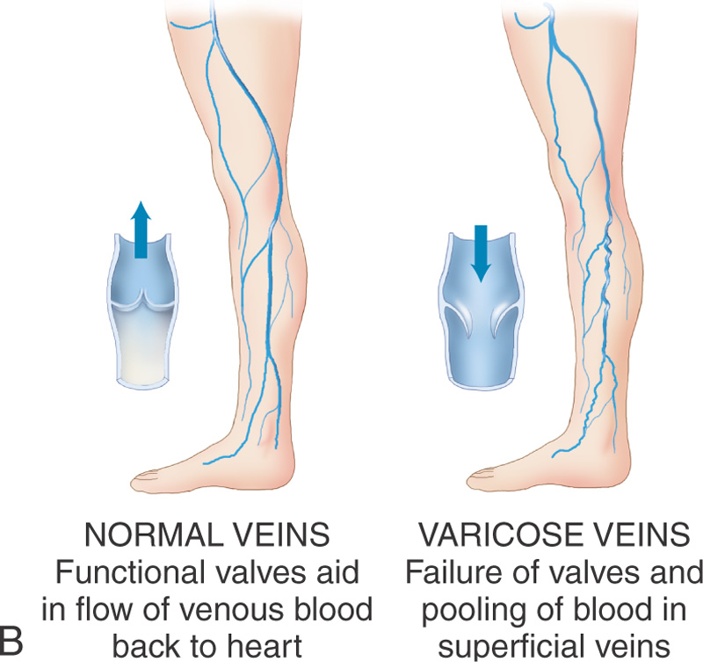
- Angiostenosis
- arteriopathy
- peripheral vascular disease
- embolus
- embolism
- Angioma
- Hemangioma
- lymphangioma
- varicose veins
- hemorrhoids
- Phlebitis
- thrombophlebitis
- venous thrombosis
- phlebostasis

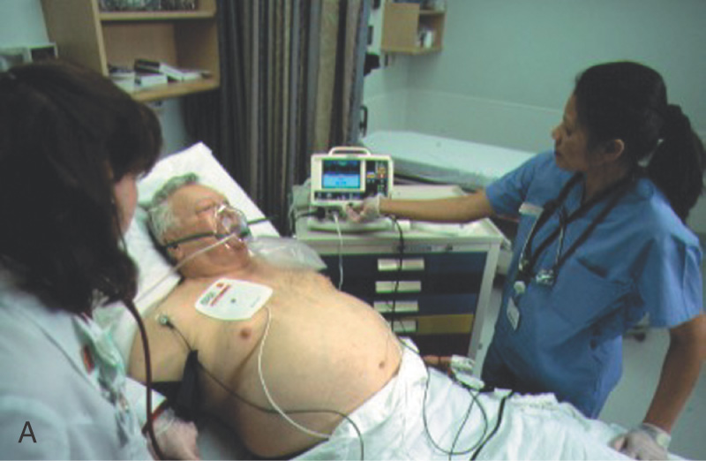
Surgical and Therapeutic Interventions
- cardiopulmonary resuscitation (CPR):
- external cardiac massage and respiration
- cardiac pacemaker
- cardioversion
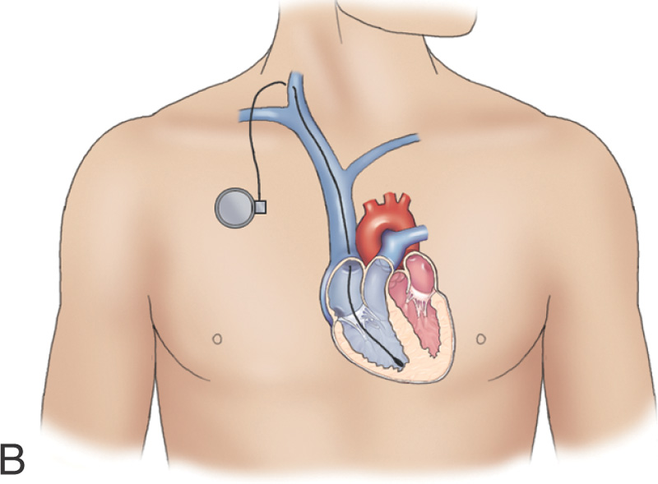
- cardioverter
- Defibrillator
- defibrillation

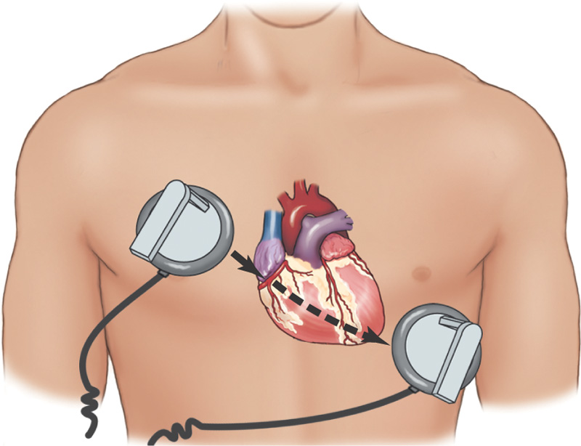
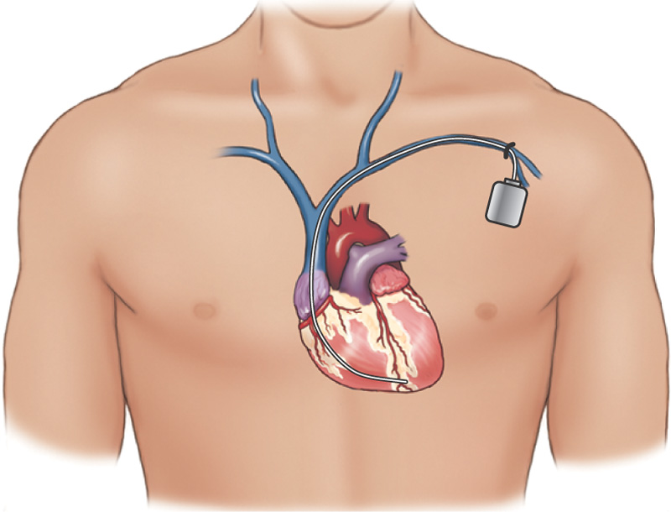

- cardioplegia, cardioplegic solutions
- cardiopulmonary bypass, extracorporeal
- coronary artery bypass, shunt
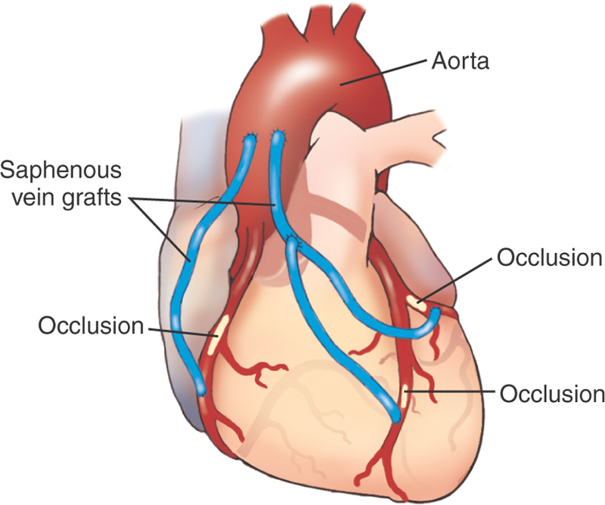
- coronary artery bypass graft (CABG)
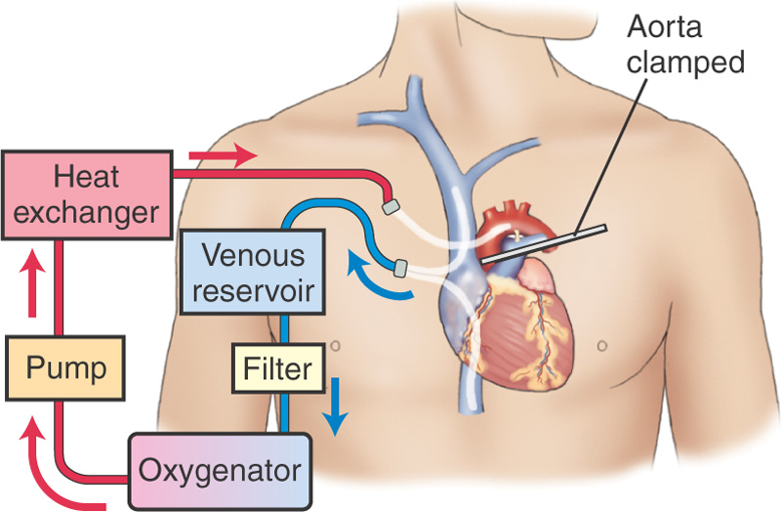

- minimally invasive direct coronary artery bypass (MIDCAB)
- off-pump coronary artery bypass (OP-CAB)
- percutaneous coronary intervention (PCI)
- What is the name of surgical repair of the septum between the atria?
- Endarterectomy
- atherectomy
- laser-assisted angioplasty
- excimer laser coronary angioplasty
- percutaneous transluminal coronary angioplasty (PTCA)
- intracoronary stent
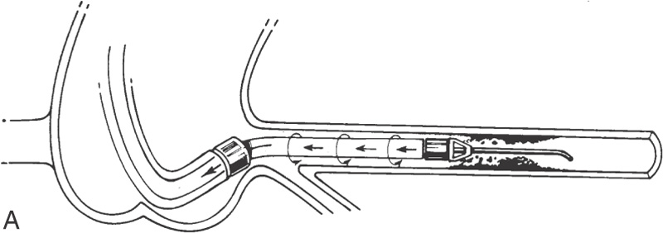
- stents

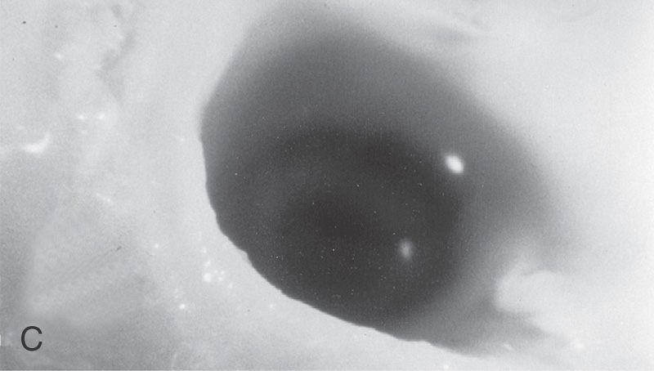
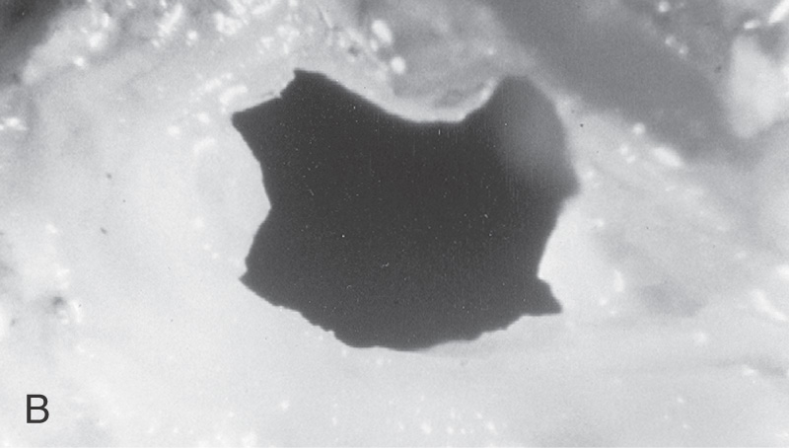

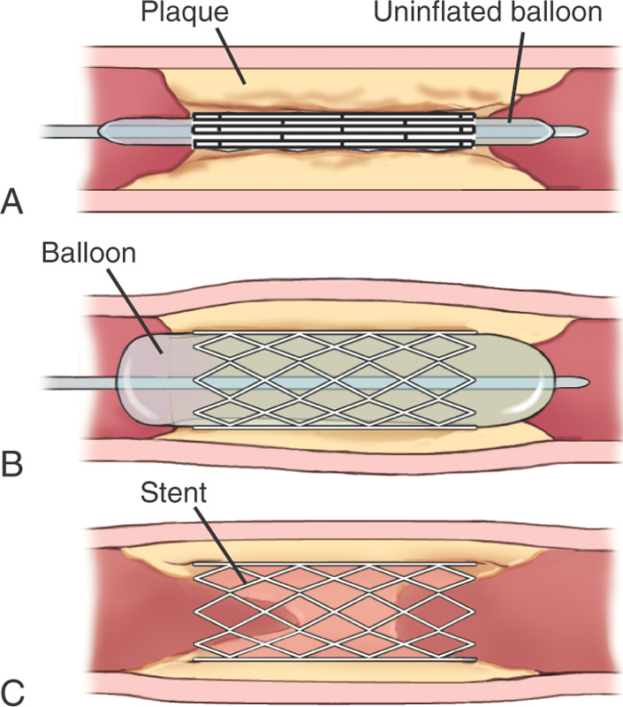
- intravascular thrombolysis
- sclerotherapy
- angiostomy
- angiotomy
- Phlebectomy
- phleboplasty
- heparin
- embolectomy
- vasodilators
- nitroglycerin
- antiarrhythmic drugs
- calcium channel blockers
- beta blockers
- digoxin
- antihypertensives
- diuretics
- antilipidemics

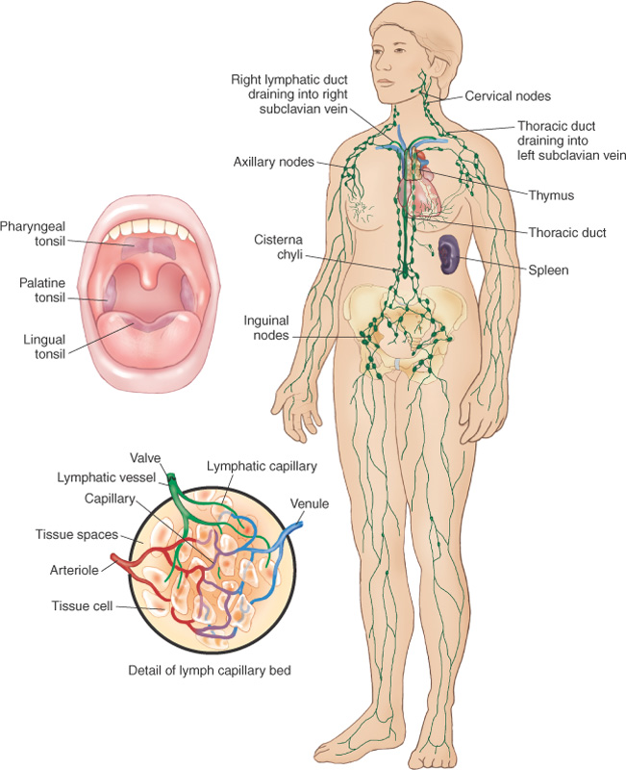
8.2
Functions of the Lymphatic System

Lymphatic System Terminology
- lymphogenous
- thoracic duct
- cisterna chyli
- lymph nodes:
  - cervical,
  - axillary
  - inguinal
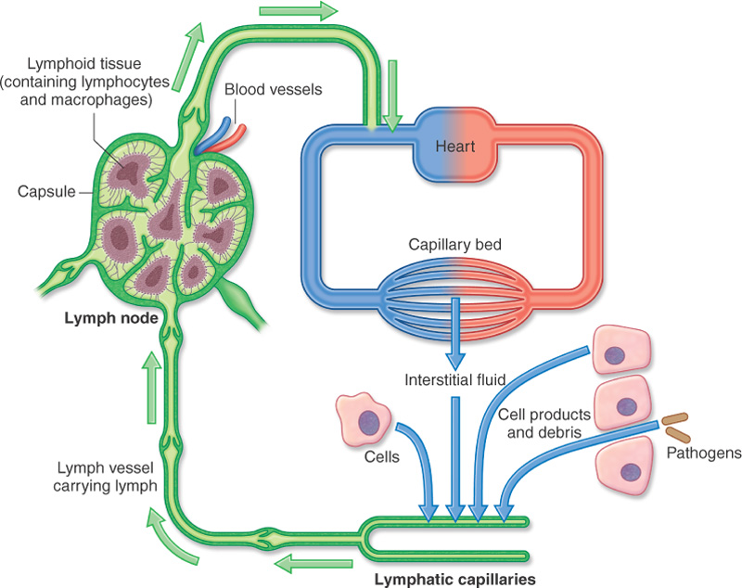
Diagnostic Test and Procedures
- Lymphography
- lymphogram
- Lymphangiography
- lymphadenography
- lymph node biopsy
- blood tests of B and T lymphocytes
Pathologies
- lymphedema
- lymphostasis
- lymphadenitis
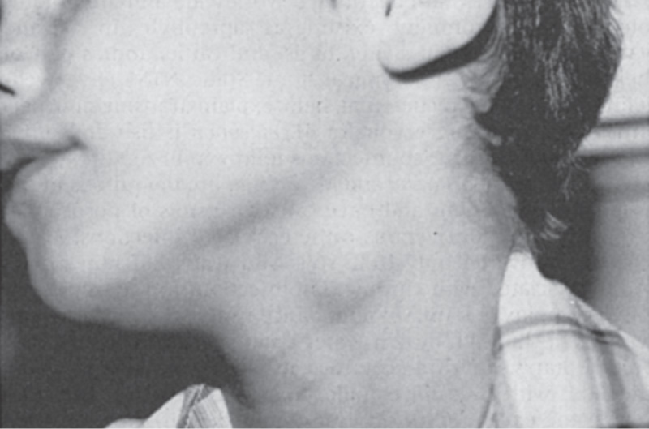
- lymphadenopathy
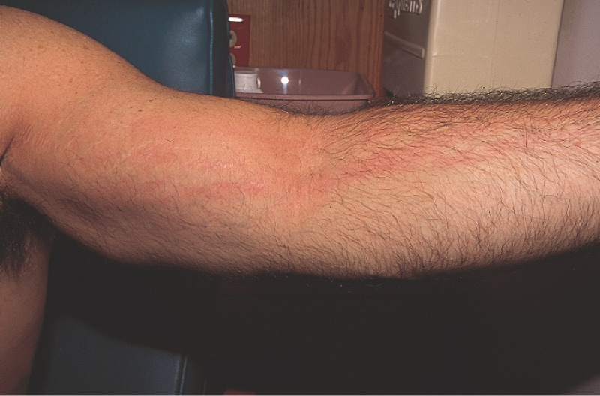
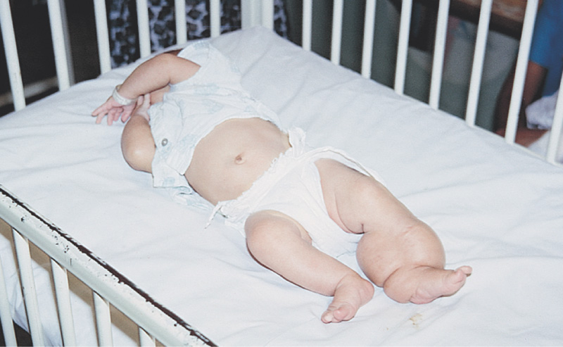
- lymphoma:
  - Hodgkin’s disease
  - non-Hodgkin’s lymphoma
- lymphatic carcinoma (metastasis)
- thymoma
- thymopathy
- Lymphangitis
- thrombolymphangitis
- Splenopathy
- Splenomegaly
- Splenorrhagia
- splenoptosis
- inflammation of the tonsils? of the adenoids?
Surgical Interventions
- lymphadenectomy
- splenectomy
- splenopexy
- splenorrhaphy
- thymectomy
- adenoidectomy
- tonsillectomy
- tonsilloadenectomy
Therapeutic Interventions
- antibiotic therapy (including penicillin)
- hot soaks
- chemotherapy
- radiotherapy
- biological therapies

